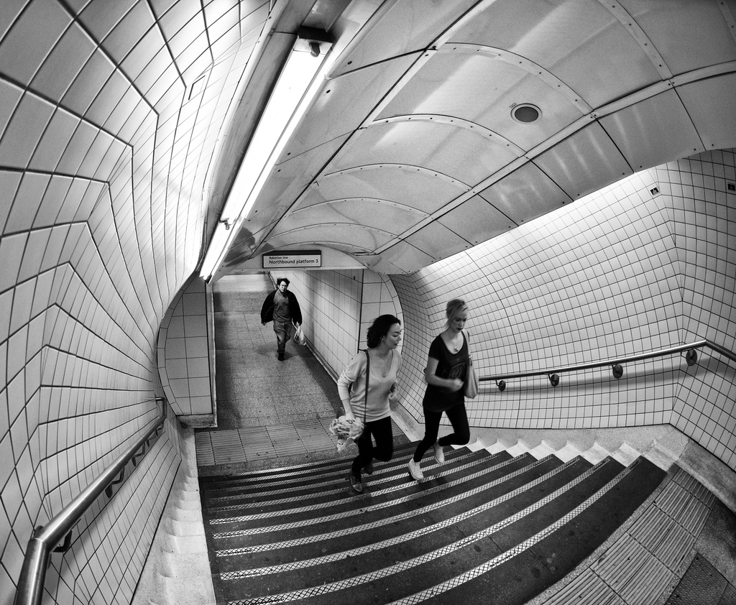

This photo shows exemplary use of leading lines, angles and perspective, to a point where it almost appears as though it is an optical illusion. This wasn't taken using a fisheye lens as the doorframe is perfectly square, but it has such an appearance due to the architecture of the walls. The lines created by the railing and the walls draw your eyes down to the center of the image to a guy carrying a bag. I like this as there is something at the visual focal point and it also doesn't allow your eyes to run off the edge of the photo. Overall this is a very simple photo but it is well thought out and well executed.